**Unit 2 – Activity 2**

**Simulating Boats**

**Part I**

Several boats move past regularly spaced buoys to reach a lighthouse. The positions of each buoy and the time at which each frog reaches the lighthouse. For each boat, Complete the code to simulate its motion. Starter code can be found <https://tinyurl.com/y723d3da>. Record your completed code in the spaces available.

1. The red boat reaches the lighthouse in 6 seconds.

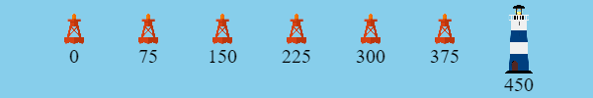

|  |
| --- |
| problem-number = 1  delta-t =  **fun** next-x(x):  **end** |

1. The purple boat reaches the lighthouse in 5 seconds.



|  |
| --- |
| problem-number = 2  delta-t =  **fun** next-x(x):  **end** |

1. The green boat reaches the lighthouse in 9 seconds.



|  |
| --- |
| problem-number = 3  delta-t =  **fun** next-x(x):  **end** |

1. The brown boat reaches the lighthouse in 6.25 seconds.

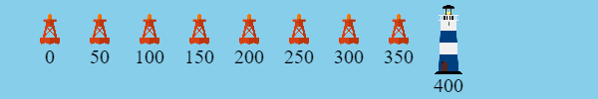

|  |
| --- |
| problem-number = 4  delta-t =  **fun** next-x(x):  **end** |

**Part II**

A group of sailors watching this are trying to determine which boat moved the quickest. Choose whichever boat you believe moved the fastest. Support your claim with whatever evidence is necessary from your simulation. Be prepared to share your claim with the rest of the class.

Notes from class discussion:

**Part III**

Graph the positions of all four boats on the graph paper below.

|  |  |  |  |  |  |  |  |  |  |  |  |  |  |  |  |
| --- | --- | --- | --- | --- | --- | --- | --- | --- | --- | --- | --- | --- | --- | --- | --- |
|  |  |  |  |  |  |  |  |  |  |  |  |  |  |  |  |
|  |  |  |  |  |  |  |  |  |  |  |  |  |  |  |  |
|  |  |  |  |  |  |  |  |  |  |  |  |  |  |  |  |
|  |  |  |  |  |  |  |  |  |  |  |  |  |  |  |  |
|  |  |  |  |  |  |  |  |  |  |  |  |  |  |  |  |
|  |  |  |  |  |  |  |  |  |  |  |  |  |  |  |  |
|  |  |  |  |  |  |  |  |  |  |  |  |  |  |  |  |
|  |  |  |  |  |  |  |  |  |  |  |  |  |  |  |  |
|  |  |  |  |  |  |  |  |  |  |  |  |  |  |  |  |
|  |  |  |  |  |  |  |  |  |  |  |  |  |  |  |  |
|  |  |  |  |  |  |  |  |  |  |  |  |  |  |  |  |
|  |  |  |  |  |  |  |  |  |  |  |  |  |  |  |  |
|  |  |  |  |  |  |  |  |  |  |  |  |  |  |  |  |
|  |  |  |  |  |  |  |  |  |  |  |  |  |  |  |  |

What patterns do you notice on this graph?

**Part IV**

Determine the speed of each boat from your graph in Part III. Show all your work.

|  |  |
| --- | --- |
| $v_{red}=$_______________ | $v_{purple}=$_______________ |
| $v_{green}=$_______________ | $v_{brown}=$_______________ |

Explain how you can find the speed of an object from a graph

We want to revise our simulation so that the boats move continuously, rather than jumping suddenly from place to place. Which parts of our code do you think need to change to accomplish this? How would you change them so that the speed of the boats doesn’t change?

Until now, we have been writing our equation of motion as

|  |
| --- |
| $$x_{next}=x+Δx$$ |

However, the value of $Δx$ depends on the particular time interval $Δt$ at which we measure. Use our new definition of speed to rewrite this equation of motion so that it will work for any value of $Δt$ we want.

|  |
| --- |
|  |

Test out this new equation of motion in your simulation of the boats. You will know that your equation works if changing the value of $Δt$ does not change the speed of the boat.

Set $Δt$ to a very small value $\left(\frac{1}{25}s\right)$ and run your simulation. What do you notice about the way your boat seems to move?